**DESIGN THINKING FOR INNOVATION**

**A PROJECT REPORT OF THE PROTOTYPE**

**CAMERA BASED FACE RECOGNITION ATTENDANCE SYSTEM**

**Submitted by**

|  |  |
| --- | --- |
| A. Madhuri | 22KQ1A0701 |
| A. Sri Kavya | 22KQ1A0702 |
| G. Amrutha Sri | 22KQ1A0710 |
| T. Akshitha | 22KQ1A0732 |
| K. Santosh Kumar | 22KQ1A0750 |
| L. Arun Kumar | 22KQ1A0753 |
| P. Varun | 22KQ1A0757 |
| V. Karthik | 22KQ1A0766 |

**OF**

**BACHELOR OF TECHNOLOGY**

**In**

**COMPUTER SCIENCE AND INFORMATION TECHNOLOGY**

**BATCH - 1**





**BONAFIDE CERTIFICATE**

Certified that this project report, “Camera Based Face Recognition Attendance System" is a bona fide work of A.Madhuri (22KQ1A0701), A. Sri kavya (22KQ1A0702), G. Amrutha Sri (22KQ1A0710), T. Akshitha (22KQ1A0732), K. Santosh Kumar (22KQ1A0750), L. Arun Kumar (22KQ1A0753), P. Varun (22KQ1A0757), V. Karthik (22KQ1A0766) in partial fulfillment of the course Design Thinking for Innovation (COURSE CODE: P21MCT04) for the academic year 2024-2025. This work is done under my supervision and guidance.

Mrs. G. Smitha Mr. N. Srinivasa Rao Assistant professor Head of the Department

Department of MBA Department of CSIT

PACE ITS, Valluru PACE ITS, Valluru

**TABLE OF CONTENTS**

|  |  |  |
| --- | --- | --- |
| S.NO | CHAPTER TITLE | PAGE NO |
| 1 | ABSTRACT | 4 |
| 2 | INTRODUCTION & OBJECTIVE | 4-6 |
| 3 | EMPATHY MAPPING | 7 |
| 4 | IMPLEMENTATION | 8 |
| 5 | RESULTS | 8-11 |
| 6 | CONCLUSION | 12 |

# ABSTRACT

This project presents a Smart Attendance System that uses face recognition to record attendance automatically. Traditional systems are time-consuming and prone to error or proxy attendance. Our system detects and recognizes faces to ensure an efficient, secure, and contactless attendance process.

# INTRODUCTION

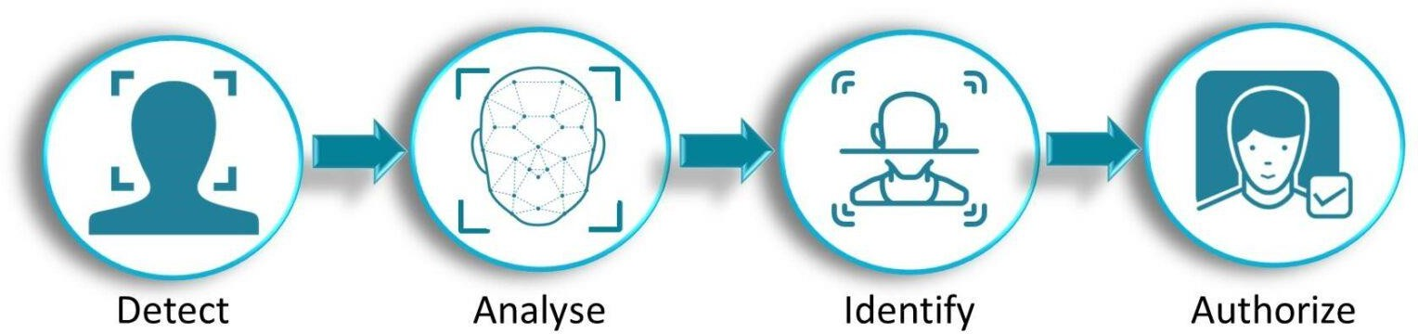

Traditional attendance systems are often time- consuming, prone to human error, and vulnerable to proxy attendance. To address these issues, smart attendance systems leveraging face recognition technology have emerged as a more secure, efficient, and automated solution.

# OBJECTIVE

The primary objective of this system is to automate attendance marking using face recognition to improve accuracy, security, and efficiency in educational institutions, offices, and other organisations.

* Develop a face recognition-based attendance system.
* Eliminate proxy attendance.
* Automate data entry and reporting.

# SYSTEM DESIGN AND ARCHITECTURE

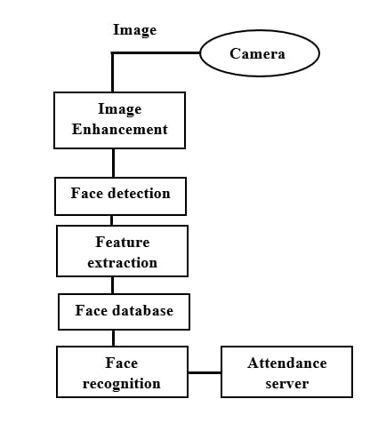

## Components:

* Webcam
* Face Detection Module (Open CV)
* Face Recognition Model (Dlib)
* Database (SQLite)

## Workflow:

1. Camera captures video.
2. Face detection occurs in real-time.
3. Extracted face is compared with the database.
4. If matched, attendance is logged with time & date.
5. Records are saved and accessible by the admin.
6. We have sent emails to students who were marked absent.

# FEATURES

* + Contactless and real-time attendance
  + High accuracy and speed
  + Eliminates proxy
  + Integration with notifications and reports
  + Scalable for large institutions

**TOOLS & TECHNOLOGIES**

|  |  |
| --- | --- |
| **Tool/Tech** | **Purpose** |
| Python | Programming Language |
| Open CV | Image Processing |
| D lib | Face Recognition |

|  |  |
| --- | --- |
| Webcam | Real-time Image Capture |
| SQLite | Database |

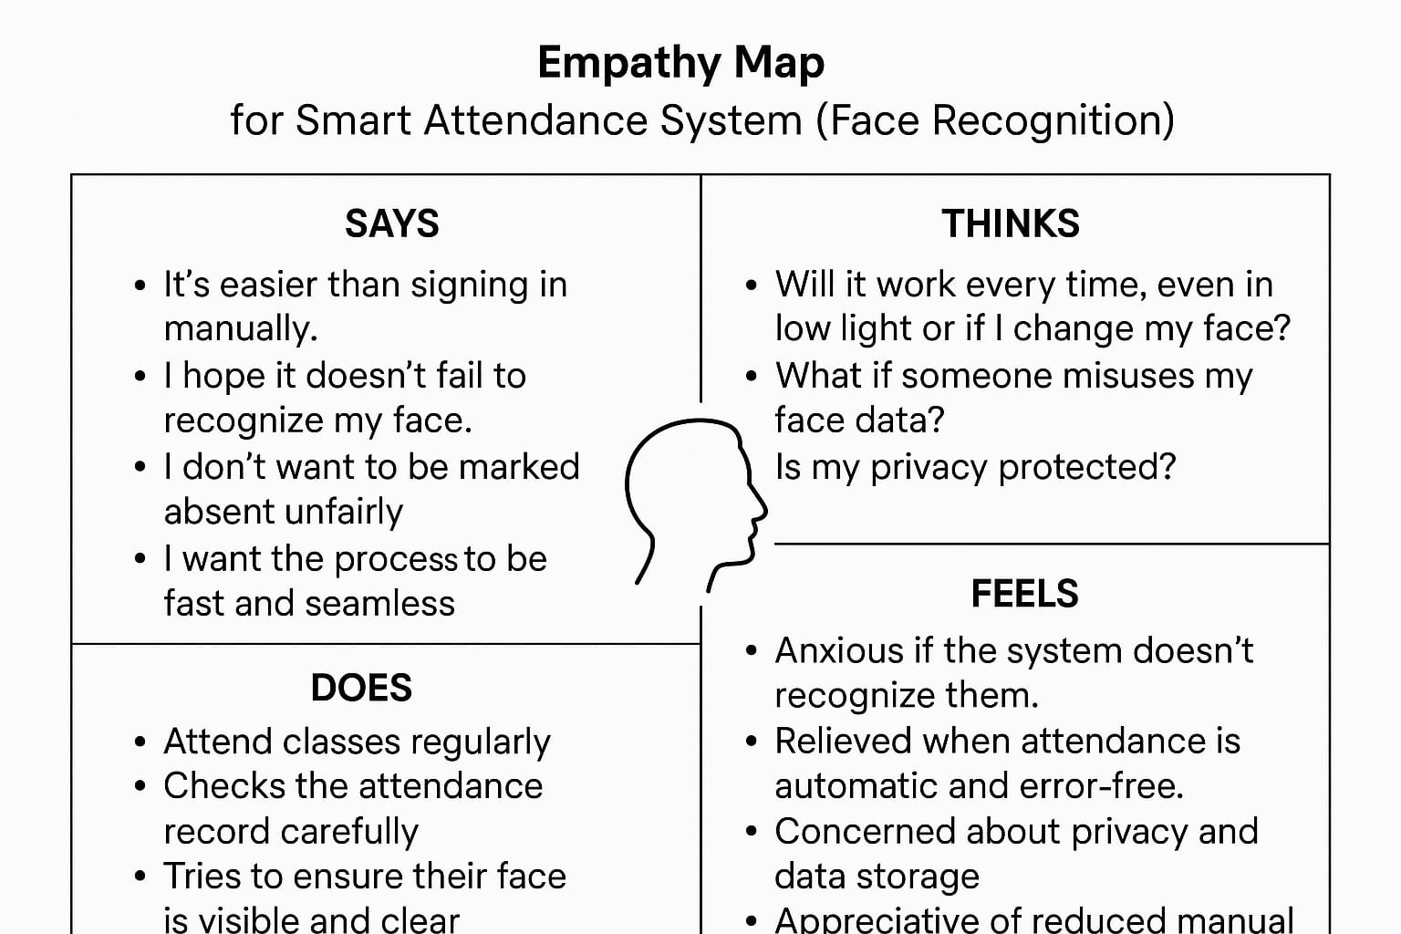

**IMPLEMENTATION**

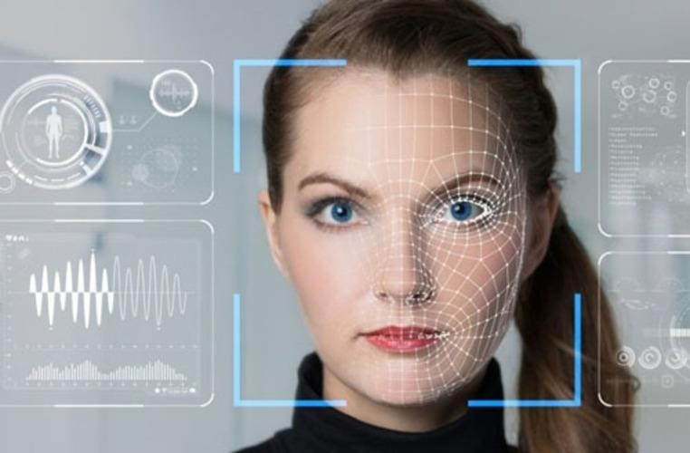

* + Faces are enrolled and stored during registration.
  + Attendance is auto marked when a recognized face appears.
  + Admin can view, export, and manage data.

# RESULTS

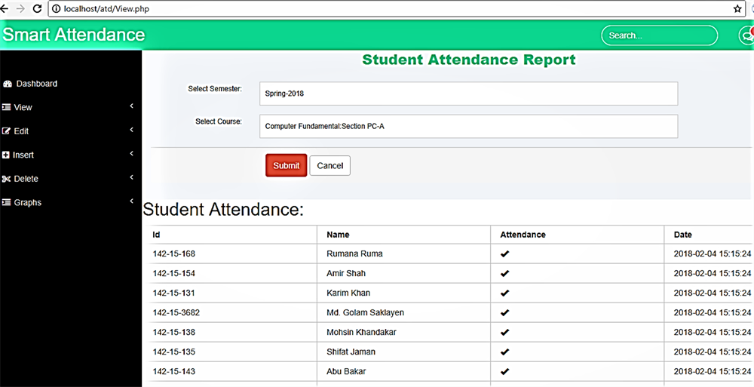

* + Attendance is marked within seconds
  + Reports are generated in EXCEL format

# ADVANTAGES

* + No physical interaction required
  + Fast and efficient
  + Difficult to spoof (unlike ID cards)
  + Easily scalable
  + Improves record management
  + Saves time during attendance collection

# LIMITATIONS

* + Accuracy depends on camera and lighting
  + Performance may drop with large datasets
  + Faces with masks or significant changes may not match
  + Privacy Concerns regarding facial data
  + Initial setup and training cost

# FUTURE SCOPE

* + Integrate with mobile app
  + Cloud-based data storage
  + Integration with school ERP systems

# APPLICATIONS

* + Schools and Colleges
  + Corporate offices
  + Events and conferences
  + Government agencies

# 1.What are the needs of the user?

# Avoid proxy attendance and human errors.

# Attendance data should be stored safely.

# Quick and automatic attendance process.

# 2.Which technology are you using for development of the product?

# Python

# Opencv

# Dlib

# Sqlite

# 3.What is the price of your product? Approx...

# High-quality 4K Camera 25k per camera.

# Additional Costs

# Storage Cost 7k.

# Cabling and Power Backup Cost 5k.

# 4.What raw material is needed for your product?

# CC Camera

# Cabling

# 5. What inspired you to innovate this product?

# Inspired by facial recognition in restaurants for tracking work hours of workers, our system monitors student engagement, detecting focus or distractions, providing an automated and secure solution for attendance.

# CONCLUSION

This project introduces a smart attendance system using facial recognition to automate and simplify the attendance process. It ensures accurate student identification, sends email alerts to absentees, and generates daily reports, offering a reliable and efficient alternative to manual methods.